GAS FLOW METER
Hardware Optimization & USS Configuration
Using MSP430FR6043 | 300/200 kHz Ultrasonic Transducers
Prepared by: SASANKA

1. Introduction
This document provides a comprehensive, step-by-step technical reference for the Gas Flow Meter project built around the MSP430FR6043 microcontroller. It covers system architecture, hardware connections, software configuration, parameter tuning, calibration methodology, and comparative analysis with legacy systems.
The core innovation of this system lies in its use of the Ultrasonic Sensing System (USS) module embedded within the MSP430FR6043, which replaces traditional zero-crossing detection with full-waveform capture and cross-correlation — resulting in significantly lower measurement drift and superior noise immunity.

2. System Overview

2.1 Key Hardware Components
Component | Model / Specification | Purpose
Microcontroller (MCU) | MSP430FR6043 (with integrated USS Module) | Central processing unit; manages ADC capture, ToF computation, and flow calculation
Evaluation Module | EVM430-FR6043 | Development/test platform for the MSP430FR6043; provides transducer connectors, jumpers, and USB interface
Ultrasonic Transducers | 300/200 kHz High-Frequency Pair | Convert electrical signals to ultrasonic waves and back; measure Time-of-Flight (ToF) difference for flow velocity
Interface / GUI | USS Design Centre GUI | Windows software for real-time parameter configuration, waveform visualization, and calibration
Firmware Tool | TI Uniflash | Flashes compiled firmware binaries onto the MCU via USB/JTAG
Host PC | Windows-based PC | Required for GUI operation, UART/USB communication, and log capture

2.2 Project Goals
- Hardware Optimization: Maximize signal quality while minimizing power consumption.
- System Calibration: Align software-computed flow values with physical reference meters.
- Zero-Flow Drift & Standard Deviation Analysis: Quantify and minimize baseline noise.

3. Software Requirements & Why Each Is Needed
Software Tool | Role | Why It Is Required
USS Design Centre GUI | Configuration and real-time monitoring | Provides a visual interface to set all USS parameters (frequency, gain, gap, pulse count) without manual register writes. Renders live waveform captures for iterative tuning.
USS Gas Flow Template | Application firmware template | Pre-configured firmware project optimized for gas metering; includes ToF algorithms, Delta-ToF computation, and flow-rate formulas ready for use.
TI Uniflash | Firmware programmer | Flashes hex/binary images onto the MSP430FR6043's FRAM via USB. Required before any measurement can begin.
Windows PC | Host platform | The GUI and Uniflash are Windows-only applications; USB-HID and virtual COM-port drivers are Windows-certified for this EVM.

4. Hardware Setup — Step-by-Step

Step 1 — Transducer Connection
Connect the two ultrasonic transducer elements to the EVM430-FR6043 board:
- Transducer 1 → Pin X1 on the EVM board
- Transducer 2 → Pin X2 on the EVM board
📌 Note: The transducers must face each other coaxially in the pipe. Misalignment degrades signal amplitude and introduces systematic ToF error.

Step 2 — Jumper Configuration
Jumper | Required Setting | Purpose
J1 | Closed / Active | Enables real-time I2C and UART communication with the USS Design Centre GUI over USB
J3 | Closed / Active | Enables the device-flashing path for Uniflash; connects USB-JTAG/SBW lines to the MCU

Step 3 — S5 Switch Position
Set the S5 switch to the ezFET middle position. This activates the on-board emulation circuit (ezFET-Lite) which multiplexes both:
- USB-JTAG debugging path (for breakpoints and register inspection in Code Composer Studio)
- Virtual COM port communication (for the GUI's live data stream)

Step 4 — LED Status Verification
After powering the board via USB, verify the following LED states before proceeding:
LED | Expected State | Meaning
LED 1 | ON (solid) | Board is powered correctly; VCC rail is stable
LED 2 | BLINKING | Active UART/USB communication with the host PC; firmware is running
LED 3 | OFF | No error condition; system is operating normally

📌 Note: If LED 2 is not blinking after firmware is flashed, check USB cable, J1/J3 jumper states, and COM port assignment in Device Manager.
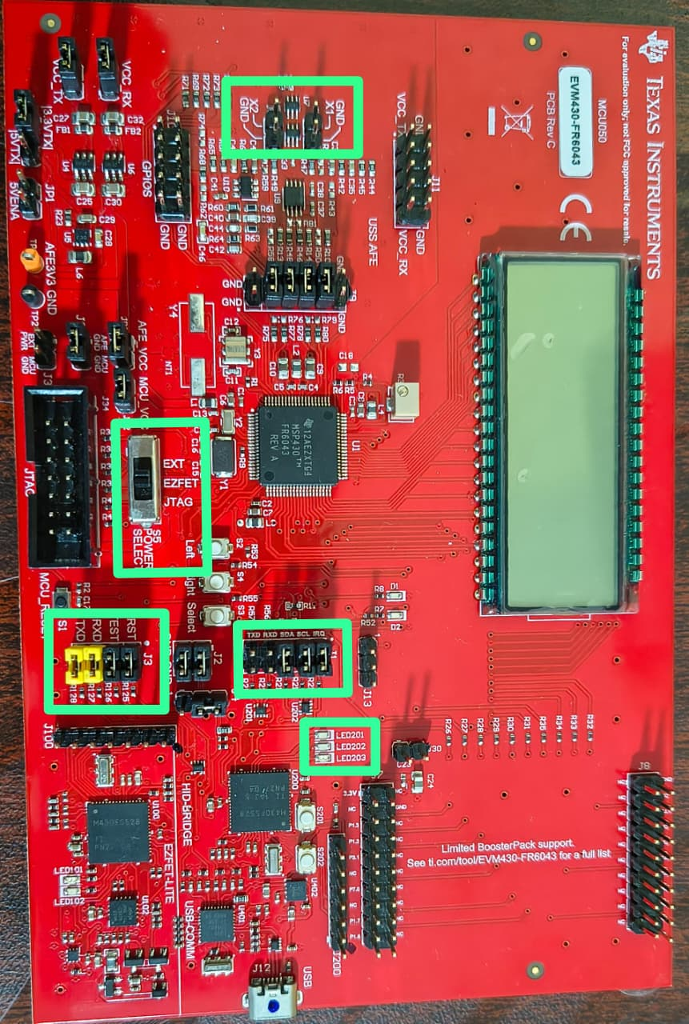

5. Firmware Flashing & GUI Configuration

5.1 Flashing Firmware with UniFlash
- Open TI UniFlash on the Windows PC.
- Connect the EVM board via USB and allow drivers to install.
- Load the latest gas flow metering firmware binary (.hex or .out) from the USS SDK.
- Click Load Image. UniFlash erases FRAM, writes the binary, and verifies the checksum.
- Power-cycle the board. LED 2 should begin blinking to confirm firmware execution.

5.2 Connecting the USS Design Center GUI
- Launch the USS Design Center GUI.
- Navigate to Options → Meter Options.
- Select EVM430-FR6043 as the target board and choose Gas mode.
- Under Communications, click Connect. The status bar should confirm a live link.
- Tape the pipe ends closed to ensure zero-flow conditions before any baseline measurement.
📌 Note: Taping the pipe during zero-flow is critical. Any ambient air movement creates a false delta-ToF offset that corrupts the baseline and all subsequent flow readings.

6. Transmitting Frequency Profile — Options & Rationale
The USS module drives the transducers with a configurable excitation waveform. Three profiles are available:

6.1 Single Tone
Aspect | Detail
Mechanism | Generates a burst of excitation pulses at one constant frequency.
Sequence | Pause → Excitation → Stop → Pause
When to use | Simple, low-noise environments where temperature does not change significantly; minimal computation overhead.
Limitation | Transducer resonance shifts with temperature. A static frequency may drift off-resonance, reduce amplitude and increase noise.

6.2 Dual Tone
Aspect | Detail
Mechanism | Extends single-tone by adding a second excitation burst at a different frequency F2.
Sequence | Pause → Excitation (F1) → Excitation (F2) → Stop → Pause
When to use | When two resonance modes need to be probed, or where a second frequency improves correlation.
Limitation | Still constrained to two fixed frequency points; may miss resonance if temperature swings widely.

6.3 F1 to F2 Sweep (Recommended for Gas Flow)
Aspect | Detail
Mechanism | Sweeps excitation continuously from F1 to F2 across a frequency range.
Purpose | Accounts for temperature-dependent resonance shifts; always excites the transducer near its current resonant peak.
Key advantage over TDC | The MSP430FR6043 (ADC-based) can use multitone/sweep profiles. Traditional TDC zero-crossing ICs are limited to a single frequency, making them unable to track resonance drift.
Effect on zero-flow drift | Dramatically reduces zero-flow drift because the excitation amplitude stays consistent across temperature.

7. Transducer Frequency Sweep — Finding Resonance

7.1 Objective
Before configuring F1 and F2 for measurement, the true resonant frequency of the installed transducer pair must be located experimentally. Transducers are specified at ~300 kHz but the actual resonance peak depends on mounting, pipe material, and coupling.

7.2 Sweep Configuration Parameters
Parameter | Value Used | Why This Value
Start Frequency | 250 kHz | Begins well below the nominal 300 kHz to capture any low-shift transducers.
Step Size | 4 kHz | Fine enough to resolve a sharp resonance peak without taking excessive time.
Number of Captures | 25 | At 4 kHz steps from 250 kHz: 250, 254, 258, ..., 346 kHz — spans ±50 kHz around nominal.
Graph to observe | Frequency Sweep Peak Amplitudes | Plots received amplitude vs. drive frequency; the tallest bar is the resonance peak.

7.3 Interpreting Results & Setting F1/F2
From the sweep graph, identify the frequency bin with the maximum amplitude. In this project, the peak amplitude was 970 ADC counts.
F1 and F2 are then set at the 50% amplitude points (half-power / -6 dB points) on either side of the peak:
Parameter | Value | Rationale
Peak Amplitude | 970 ADC counts | Highest received signal; corresponds to true mechanical resonance of the transducer pair.
50% of Peak | 485 ADC counts | Half-power points define the -6 dB bandwidth of the transducer.
F1 (lower -6 dB point) | 275 kHz | Left edge of usable bandwidth; below this, amplitude falls too low for reliable ToF extraction.
F2 (upper -6 dB point) | 320 kHz | Right edge of usable bandwidth; beyond this, amplitude again falls below reliable threshold.
Sweep Range in Operation | 275 – 320 kHz | Covers the full resonance bandwidth; ensures the MCU always excites the transducer within its useful range regardless of temperature.

8. ADC Capture & Signal Alignment

8.1 ADC Specification
The MSP430FR6043 integrates a 12-bit sigma-delta ADC with a programmable gain amplifier (PGA). The full-scale range covers −2048 to +2048 counts, representing the complete ultrasonic waveform envelope.

8.2 Target ADC Amplitude — ±900 Counts
Zone | ADC Count Range | Interpretation
Noise Floor | < ±150 counts | Signal is indistinguishable from background noise; ToF extraction unreliable.
Target Operating Range | ±900 counts | Signal-to-noise ratio is high; cross-correlation yields accurate ToF. This is the tuning target.
Over-driven Zone | > ±1500 counts | Background noise rises above ±150 counts, corrupting ToF accuracy through noise-induced correlation errors.
Hard Clip / Saturation | > ±2048 counts | ADC rails; waveform is clipped and ToF cannot be determined.

📌 Note: In this project, optimal PGA gain was determined to be 7.7 dB, which places the received signal amplitude squarely in the ±900 count target zone.

8.3 PGA Gain — Purpose & Tuning
The Programmable Gain Amplifier (PGA) amplifies the received ultrasonic signal before ADC sampling. Gain is adjustable in the GUI.
- Too low: signal < ±150 counts → dominated by noise, unreliable ToF.
- Optimal (7.7 dB here): signal ~±900 counts → high SNR, accurate cross-correlation.
- Too high: background noise > ±150 counts → noise contaminates correlation peaks, degrading ToF accuracy.

8.4 Capture Gap — 210 µs — Purpose & Tuning
The capture gap is the time delay between the start of the transmit pulse and the start of ADC sampling. It aligns the ADC capture window with the received ultrasonic burst.
Action | Effect | Reason
Increase Gap | Waveform shifts LEFT in capture window | ADC starts sampling later; the echoes arrive proportionally earlier in the window.
Decrease Gap | Waveform shifts RIGHT in capture window | ADC starts sampling sooner; echoes appear later in the window.
Target | Waveform cantered in window | Maximizes usable samples on both sides of the peak, improving cross-correlation accuracy.

📌 Note: In this project, a gap of 210 µs was found optimal to centre the 300 kHz burst within the ADC capture window.

8.5 Number of Excitation Pulses
Increasing the number of transmitted pulses has the following trade-offs:
Pulses | Signal Strength | Noise Rejection | Power Consumption
Few | Weak amplitude | Lower; single burst is susceptible to single-event noise | Low
More (chosen) | Higher amplitude | Better averaging; noise artifacts average out across pulses | Higher

For zero-flow conditions where precision matters most, more pulses were selected to minimize standard deviation of ToF readings at the cost of slightly higher power consumption.

9. Calibration & Volumetric Analysis

9.1 Meter Constant
The Meter Constant is a multiplicative scaling factor that converts the raw gas velocity computed from Delta-ToF into volumetric flow rate (L/h or L/min). It accounts for:
- Pipe cross-sectional area
- Transducer placement angle and acoustic path geometry
- Any systematic offset between acoustic velocity and bulk fluid velocity
Adjustment procedure: Compare the GUI-displayed flow rate with a calibrated physical reference meter. Increase or decrease the Meter Constant until both agree across the target flow range.

9.2 Real-Time Monitoring Parameters
Parameter | Description | Why Monitor It
Delta ToF (ns) | Difference in Time-of-Flight between upstream and downstream directions | Directly proportional to gas flow velocity; the primary measurement quantity.
Absolute ToF (µs) | Total transit time of ultrasonic signal (either direction) | Used to compute speed-of-sound, which varies with gas temperature and composition.
Volume Flow Rate (L/h) | Calibrated output derived from Delta ToF × Meter Constant | Final engineering output consumed by billing systems or displays.

9.3 Measurement Results
Condition | Parameter | Mean | Sigma (Std. Dev.)
Zero Flow (pipe taped) | Volume Flow Rate (L/h) | −0.24 | 1.58
Zero Flow (pipe taped) | Delta ToF (ns) | −0.33 | 1.31
10 L/min Air Flow | Volume Flow Rate (L/h) | ~600 | 56.75
10 L/min Air Flow | Delta ToF (ns) | 587.8 | 56.27

📌 Note: Zero-flow mean close to 0 (−0.24 L/h) confirms a well-calibrated baseline. The small sigma (1.58 L/h) demonstrates excellent system stability under no-flow conditions.

10. Consolidated Parameter Reference Table
The following table summarizes every key parameter used in this optimized setup, along with the reasoning for each value choice.

Parameter | Value | Purpose | Effect If Wrong
Transducer Frequency | 300 kHz nominal | Determines acoustic wavelength in the gas; affects sensitivity and pipe diameter compatibility. | Incorrect frequency → wrong resonance tuning → low amplitude.
Sweep Start | 250 kHz | Lower bound of resonance search sweep. | If too high, misses downward-shifted transducers.
Sweep Step | 4 kHz | Resolution of resonance peak identification. | Too coarse → peak amplitude underestimated; F1/F2 set incorrectly.
Sweep Captures | 25 | Number of frequency bins sampled. | Too few → resonance peak may fall between bins.
F1 (lower edge) | 275 kHz | Lower operating frequency for F1–F2 sweep excitation. | If below transducer bandwidth → weak signal.
F2 (upper edge) | 320 kHz | Upper operating frequency for F1–F2 sweep excitation. | If above transducer bandwidth → weak signal.
PGA Gain | 7.7 dB | Amplifies received signal to ±900 ADC counts. | Too high → noise exceeds ±150; too low → signal lost in noise.
ADC Target Amplitude | ±900 counts | Optimal SNR zone for cross-correlation. | < ±150: noise; > ±1500: noise rises and distorts correlation.
Capture Gap | 210 µs | Aligns ADC sampling window with received burst. | Off-centre → correlation uses partial waveform → poor ToF accuracy.
Number of Pulses | Increased (project-specific) | Boosts signal energy and averaging, reducing noise. | Too few → higher sigma; too many → excess power consumption.
Meter Constant | Calibration-adjusted | Scales Delta-ToF to volumetric flow rate. | Wrong → systematic flow rate error across all measurements.

11. Conclusions
The gas flow meter developed on the EVM430-FR6043 platform demonstrates that:
- Full-waveform cross-correlation is fundamentally superior to zero-crossing detection for precision gas metering.
- Frequency sweep excitation (F1–F2) compensates for temperature-dependent transducer resonance shift, drastically reducing zero-flow drift.
- Careful ADC gain tuning (7.7 dB → ±900 counts) ensures measurements stay in the high-SNR operating zone.
- Capture gap alignment (210 µs) maximizes the usable waveform within the ADC sampling window.
- Calibration via the Meter Constant provides a straightforward path to match any pipe geometry or flow range.
This solution offers a scalable, low-power, and highly accurate platform for modern gas metering applications.

